1. **Creating sample deployment in Kubernetes.**

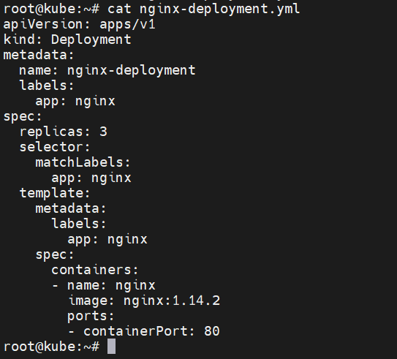

**To run deployment file.**

**# kubectl apply -f nginx-deployment.yml**

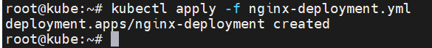

**To check whether deploy is created.**

**# kubectl get deploy**

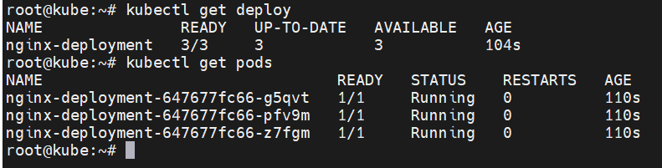

**This is the magic. Both deploy and pods created.**

1. **To check what exactly happening with the pods in live.**

**# kubectl get pods -w**

**Here we tried to delete pod with below command. But it it got auto created due to deployment file. This is an example of Kubernetes auto healing.**

**# kubectl delete pod nginx-deployment-647677fc66-g5qvt**

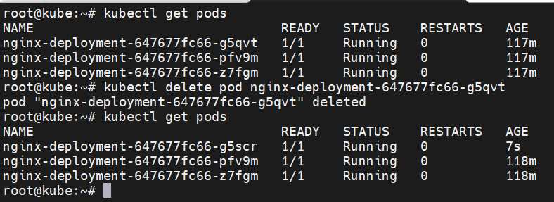

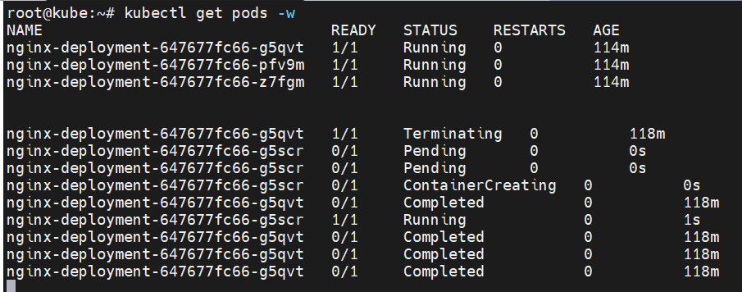

1. **To check replica set.**

**# kubectl get rs**

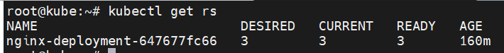

1. **In production environment, you create a deployment and never create a pod directly. Through deployment your pods will get created as we see the same example above.**